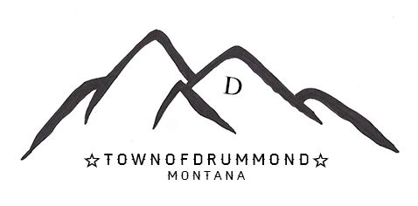
TOWN COUNCIL MEETING AGENDA
TUESDAY, JANUARY 23, 2024 7:00PM
DRUMMOND TOWN COUNCIL CHAMBERS, 114 “A” STREET, DRUMMOND, MT 59832
Agenda items must be submitted by Noon on the 2nd Tuesday of each month.

- CALL TO ORDER
- PLEDGE OF ALLEGIANCE
- GUESTS
- Loren Flynn, representing Missoula FWP; Ann Marie Johnson. Representing Helena FWP
- PUBLIC COMMENT

- LAW ENFORCEMENT

- CONSENT AGENDA
- MINUTES – Written – December Regular Meeting
- CLAIMS - Printed from System
- CORRESPONDENCE
- Investments – Printed Spreadsheet
- FINANCIALS

- ACTION ITEMS
- Approval to Shred Blank Checks; Due to Bank Ownership Transfer.

- MAYOR’S REPORT
- Headwaters Update
- MT League Update
- TOWN ATTORNEY

- PARKS
- FWP (Fish, Wildlife and Parks) Fishing Boat Access Agreement; Loren Flynn, representing Missoula FWP

- ROADS
- Tow Sign Enforcement (Broad Street)
- FLOODPLAINS

- SEWER
- Engineer Brad Koon, Triple Tree Engineering – WWTF Upgrade Update.
- CITY COURT

- NEW BUSINESS

- OLD BUSINESS

AJOURNMENT: NO LATER THAN 10 PM
THE NEXT MEETING WILL BE TUESDAY, FEBRUARY 20, 2024 AT 7PM

